SLE-3: Architectural Design (Full C4 Model)
Tic-Tac-Toe Search Agent: Minimax vs Alpha-Beta Pruning
Course: 02AML204 – Introduction to Artificial Intelligence
PRN: 25UAM099
Name: Nikesh Rathod
Division: B
GitHub / Portfolio Link: https://github.com/rnikesh7218-maker

1. System Title & Short Description
This is the Tic-Tac-Toe search agent from my SLE-2. It is a small Python program that looks ahead through all possible moves to find the best result X can get when both players play perfectly. It does this in two ways: plain Minimax, and Minimax with Alpha-Beta Pruning, which skips branches that cannot change the answer. The program also measures running time and the number of positions searched for three test boards, so the two algorithms can be compared.

2. Context Diagram (Level 1)
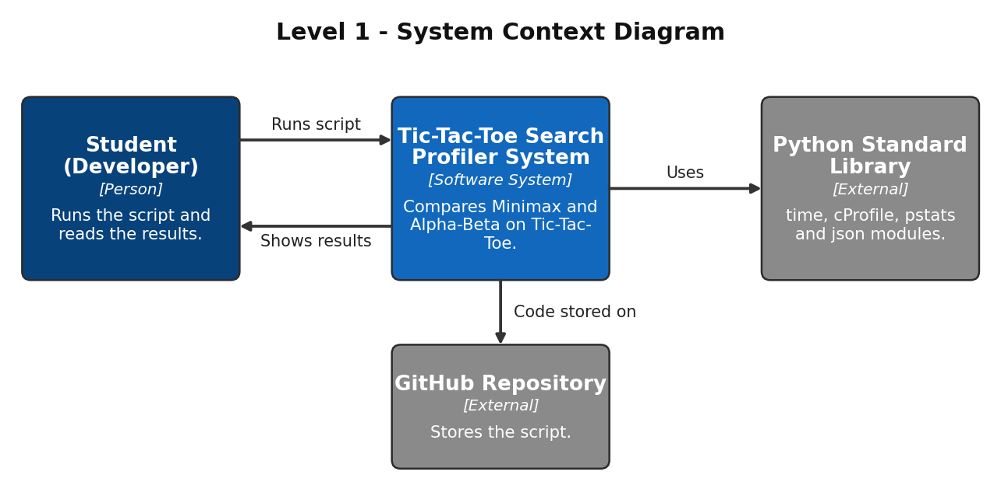
The Student runs the script and reads the results. The whole program is shown as one box at this level. It uses Python's standard library (time, cProfile, pstats and json) for timing, profiling and saving results. The script is stored on GitHub.

3. Container Diagram (Level 2)
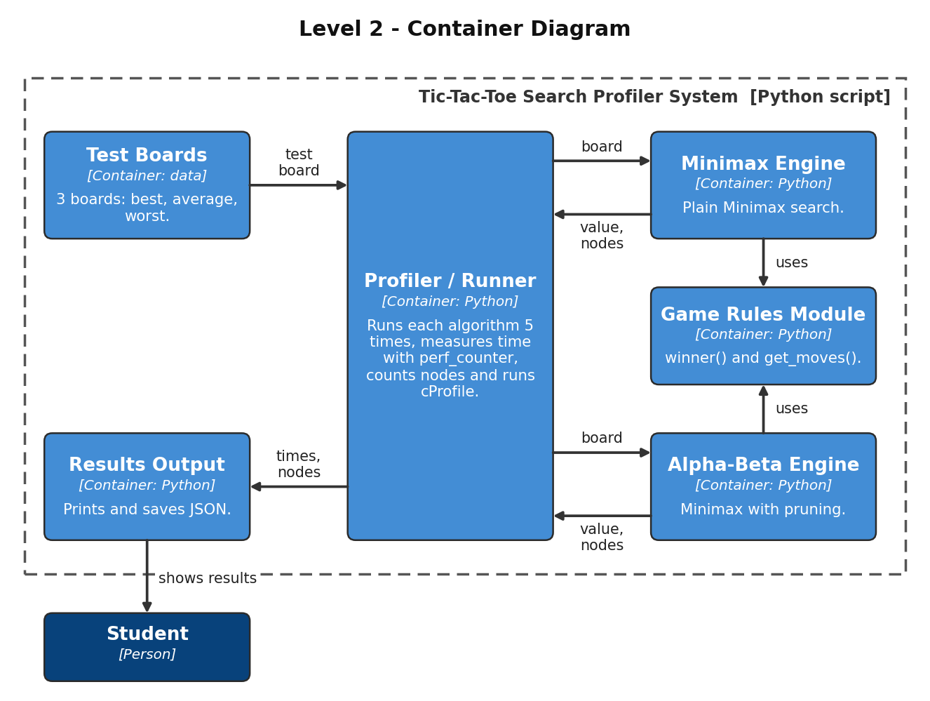
- Test Boards: three fixed boards (best, average and worst case) used as input.
- Profiler / Runner: runs each algorithm 5 times per board, measures time with perf_counter, collects the node count and runs cProfile.
- Minimax Engine: plain Minimax search; X is MAX and O is MIN.
- Alpha-Beta Engine: the same search with pruning, so it visits fewer positions.
- Game Rules Module: winner() and get_moves(), shared by both engines so the rules are identical.
- Results Output: prints the results and saves them in results.json and profile.json.

4. Component Diagram (Level 3)
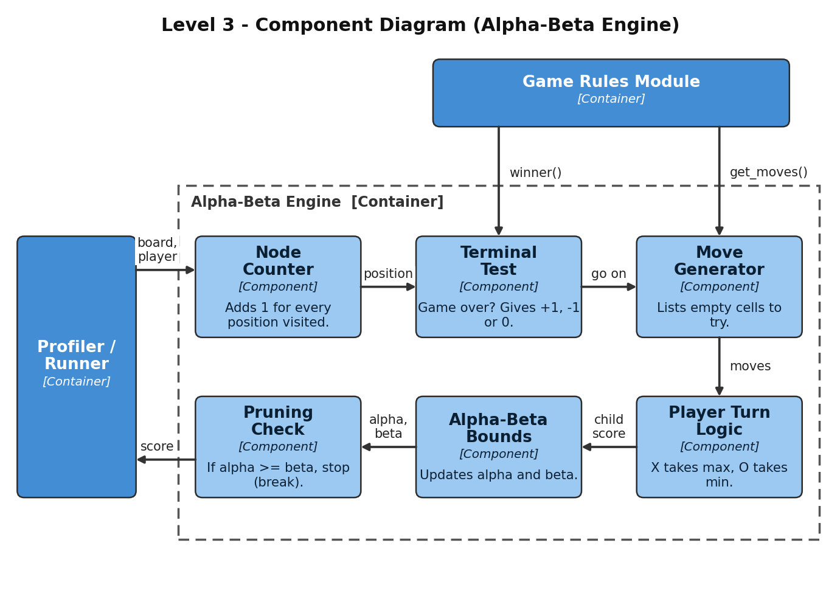
I chose the Alpha-Beta Engine because it is the main idea of the project. Node Counter adds 1 for every position visited. Terminal Test checks if the game is over and returns +1, -1 or 0. If not, Move Generator lists the empty cells. Player Turn Logic lets X take the highest score and O the lowest. Alpha-Beta Bounds updates alpha and beta, and Pruning Check stops the loop when alpha >= beta.

5. Code Level Overview (Level 4)
The program is written with functions only (no classes).
- WIN_LINES, TESTS : data: the 8 winning lines and the 3 test boards.
- def winner(b) : Game Rules; returns 'X', 'O' or None.
- def get_moves(b) : Game Rules; returns the list of empty cells.
- def minimax(b, player) : Minimax Engine; returns +1, 0 or -1 for the board.
- def alphabeta(b, player, alpha, beta) : Alpha-Beta Engine; same result with pruning.
- def run_minimax(board) / run_alphabeta(board) : Runner; run one search and return (value, nodes).
- if __name__ == "__main__": : Runner and Output; times 5 runs, runs cProfile, saves JSON.

6. Design Decisions
I wrote Minimax and Alpha-Beta as two separate engines but made them use the same Game Rules and the same move order (cell 0 to 8), so the comparison is fair. The profiling code is kept in the Runner, outside the engines, so measuring does not change how the algorithms work. A board is just a list of 9 cells, which keeps the code short and easy to explain. Results are saved in JSON so charts can be made from them later.

7. AI Contribution Note
AI tools used: Claude (Anthropic).
What AI helped with: Writing the Minimax / Alpha-Beta and profiling code in SLE-2, explaining the C4 model, drawing these diagrams and drafting this report.
What I did myself: Chose Minimax vs Alpha-Beta as my system, checked that the diagrams match how my program works, and prepared to explain each level and design choice in my own words.

8. Conclusion
C4 helped me look at the same program from the big picture down to the functions. The context level shows who uses the system, the container level shows its main parts, the component level shows what happens inside the Alpha-Beta Engine, and the code level lists the functions. I learned that giving each part one job, like keeping the game rules separate from the search, makes the design easier to explain and to change.

